St. Luke Catholic Church
7575 Holliday Drive East
Indianapolis IN 46260
Sister Diane Carollo, S.G.L., Director of Religious Education
Tel. 317-259-4373, ext. 256
dcarollo@stluke.org

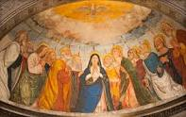

Confirmation Program Handbook 2023-24

“When the day of Pentecost came, they were all together in one place. And suddenly from heaven there came a sound like the rush of a violent wind, and it filled the entire house where they were sitting. Divided tongues, as of fire, appeared among then. All of them were filled with the Holy Spirit and began to speak in other languages, as the Spirit gave them ability.” Acts 2:1-4

Topic Page(s) in Handbook

Confirmation letter to parents from Sister Diane 2-3
Welcome to the Confirmation Program 4 25 Required Service Hours 5-7
What is MobileServe? 7-8
FORM A Confirmation Certificate of Eligibilty 9
FORM B Confirmation Sponsor Paper 10 About Choosing a Confirmation Name 11
FORM C Confirmation Name Essay 12
FORM D Essay on a Christian Service Project 13
Instructions on Letter to the Archbishop 13-14
What to do at adoration 15-16
How to Pray the Rosary 17-21
How to Pray the Divine Mercy Chaplet 22
Prayers and Teachings to Know 23-25

June 30, 2023
Dear Catholic Parents/Guardians,
As we approach a new scholastic year in August, I want to invite you to register your eighth-grade son or daughter for the Confirmation Program at St. Luke Parish. However, before you register your child for the sacrament, it’s important to note that there are certain requirements and expectations during this year of sacramental preparation.
Please note on your calendars that we have a mandatory orientation meeting for parents of eighth-grade students on Thursday, September 21, at 6:30 p.m., at St. Luke Church. The meeting will be in the All Saints/Father McGivney rooms that are located by the new school entrance. The orientation should answer all the questions you may have regarding the Confirmation Program and its requirements. This meeting is only for the parents.
As you know, the Church teaches us that baptism is the first sacrament Christians receive. As such, it is the “basis of the whole Christian life” (Catechism of the Catholic Church, 1213). Baptism gives sanctifying grace, which begins the divine life within the soul (see Catechism of the Catholic Church, 1266). We know that baptism begins the spiritual life but we also believe that Confirmation “brings an increase and deepening of baptismal grace.”
The increase in the spiritual life is closely related to the special strength poured out by the Holy Spirit on the individual at Confirmation. Confirmation unites that person more firmly to Christ, increases the gifts of the Holy Spirit within him or her, and binds him or her more perfectly to the Church. In addition, it gives the baptized Catholic the grace to bear witness to the Faith and to act a witness to Jesus Christ (see Catechism of the Catholic Church, 1303).
At your child’s baptism, you made a promise to God to raise your child as a Catholic. Thank you for educating your child in the Faith at home, enrolling him at St. Luke Catholic School or Sunday Morning Religious Education (SMRE). Your decision to share the richness of our Catholic faith at home and provide your child with a formal Catholic education means that you have taken your commitment seriously. We hope that your child is also beginning to live out his or her Catholic faith in practical and meaningful ways. This will help your child in making an informed choice to be confirmed in 2024.
There are a number of expectations during the Confirmation Program that will be discussed at the upcoming parent meeting on September 21. However, one important expectation that I want to emphasize in this communication is that during this year of sacramental preparation parents need to actively encourage their children to worship at Mass on Sundays and holy days of obligation.

Since the Eucharist is the Source and Summit of our Catholic Christian life, the religion teachers at school and in SMRE look forward to working together with you to ensure a solid preparation for your child in his/her preparation for Confirmation. Without Sunday worship, this preparation is undermined.

Unless there are extenuating circumstances, such as illness or caring for a sick person, Catholics are obliged to go to Mass on Sundays. Note that the obligation to go to Mass is binding under the penalty of grave or mortal sin.

Apart from the obligation to worship God, I want to stress that going to Mass and receiving the Eucharist and going to confession regularly are critical to the ongoing spiritual formation of your child, especially during this year of preparation for Confirmation.

I look forward to seeing you at the September 21 meeting for parents. Again, if you want to register your son of daughter for Confirmation, go to https://www.stluke.org/worship/sacraments . If you prefer to print off the registration sheet, please feel free to fill it out, enclose a check and send it to me at the parish office.
Please make sure you use the proper form for your child.

Have a blessed remainder of the summer!
In the Lord of Life, Sister Diane Carollo, S.G.L. Director of Religious Education dcarollo@stluke.org

Welcome to the Confirmation Program

Welcome to the St. Luke Confirmation Program. Preparation for the sacrament is offered in the 8th grade. The date in August 2024 is still to be determined. By mid-August we will publicize the date on the parish calendar.

Students enrolled at St. Luke School are prepared for Confirmation during the week. All other 8th grade students in public and private non-Catholic school settings, and even those attending Catholic High Schools, may prepare for the sacrament of Confirmation should by attending the SMRE (Sunday Morning Religious Education) Confirmation Program from 10:45-11:50 a.m. Check out the SMRE calendar on the parish website at https://www.stluke.org/worship/reigious_education/elementary_religious_education .

Registering 8th grade students at St. Luke School or enrolled in SMRE
Note that parents of students in grade 8 at St. Luke School also need to register their children for Confirmation. Go to https://www.stluke.org/worship/sacraments .
A copy of your child’s baptism certificate will be required for both SMRE and St. Luke School students. Please make sure the school office has your child’s certificate on file.

If you wish to register off-line, use the registration sheet provided, fill it out and return it with the fee and a copy of your child’s baptism certificate to the parish office.

The required Confirmation Retreat
The Confirmation Retreat is scheduled for January 27, 2024. It will be conducted by Camp Rancho Framasa team members at St. Luke Parish. Parents are asked to drop off their children at 8:45 a.m. and pick them up at 2:00 p.m. Lunch and snacks will be provided. The retreat is required.
Confirmation Fees
SMRE students pay $85. per child for the Confirmation Program. St. Luke School students fee is $45. The SMRE tuition includes book fees. The St. Luke School students pay a separate book fee. The fee for all students covers the cost of the retreat, retreat team expenses, MobileServe, and other hidden expenses associated with the Confirmation Program.

The Curriculum

St. Luke School and SMRE students will be using two new books from Loyola Press. Finding God and Confirmed in the Spirit will be the primary books used in the classroom. As stated by the publisher, Finding God Grade 8 Young People's Book explores the life of Jesus Christ and the authentic teachings of the Catholic Church. Each Young People’s book comes with access to the new Finding God 7–8 App that contains engaging and thought-provoking faith-filled multimedia. Confirmed in the Spirit provides young people with the comprehensive, core preparation they need to receive the Sacrament of Confirmation.

REQUIRED SERVICE PROJECTS

25 Hours of Christian Service
The Church teaches us that it is the responsibility of the baptized to live the Gospel in the world. The Confirmation Program teaches your sons and daughters to actively preach and spread the Gospel through their daily activities at home, school, parish and community.

Of course, the service project is never an end in itself. It’s not something to scratch off the list of Confirmation requirements. Christian service projects should teach your children that loving service pleases God and benefits our neighbor. In a very practical sense, Christian service projects should direct youth to love God and neighbor.

The Confirmation Service Hours are recorded by MobileServe. Emails for all the parents will be submitted to MobileServe. Please respond to MobileServe to activate your child’s account. Note that if you have more than one child using MobileServe, you will need an additional email.

25 Hours of Christian Service

Service needs to be completed in the following three areas no later than May 31 for St. Luke School and SMRE candidates:

1. Prayer and Public Witness
2. Parish and/or School
3. Community
4. Domestic Church

Each category for service should be selected. Of the total 25 hours, no category should have less than 3 hours. For example, a student may choose 16 hours of Parish/and or School Service, 3 hours for Prayer and Public Witness, 3 hours for Community, and 3 hours for Domestic Church. Other combinations are possible. A student may even exceed the 25 hours of service. In fact, many candidates do exceed the required number of service hours! Acknowledgement of the top three students who complete the most hours will be made at the Confirmation Mass in August 2024 at St. Luke Parish.

Throughout the year, there will be service projects offered in the parish and school that count toward the service requirement.

Candidates may not benefit directly from the service they perform. For example, the hours required to raise money for a school trip to Washington, D.C. will not count toward the service hours. If the candidate works beyond the hours required, he/she may earn Christian Service hours.

Altar servers may not accept money for funerals or weddings. They may serve a funeral or wedding, but if they receive payment, they may not count the time toward Christian service. An altar server may accept the money and give it to Monsignor Schaedel to put in a charity fund of his choosing. Monsignor Schaedel may also allow the altar server to designate a charity.

More on the Christian Service Categories

Under the category of PRAYER AND PUBLIC WITNESS, your child may participate in public displays of our Catholic faith that are planned in the parish or archdiocese.

For example, participation in youth events and retreats sponsored by St. Luke Parish or the archdiocese count toward Christian Service hours. Leighann Eckrich is our parish youth minister. You may contact her at leckrich@stluke.org to learn more about activities that provide hours for Confirmation Service.

- Altar serving. Contact Msgr. Schaedel at jschaedel@stluke.org .

- Singing in the parish and school choirs. Contact Mr. Tom Nichols at tnichols@stluke.org .

- Weekday Masses – School Masses are not included! They may be included if an altar server is absent and a substitute is needed.

- Praying in our perpetual adoration chapel. The supervisor may be the parent or parishioner who is present while the candidate is in adoration. MobileServe must still be used.

2. Under the category of PARISH and/or SCHOOL, your child may participate in a wide variety of tasks and events.

- Service hours may be gained through all types of approved events on the parish or school calendars. If there is a question about the type of service, please email me at dcarollo@stluke.org . Although both the school’s Passion Play and May Crowning are required of the 8th grade students, the powerful and moving spiritual events will count toward PRAYER AND PUBLIC WITNESS. These two required events are the only exceptions that allow candidates to gain Christian Service hours for each event. The teacher will determine the number of hours to be gained.

To gain Christian Service Hours through 8th grade religious initiatives such as the Passion Play and May Crowning, contact Mr. Michael Mazzei at mmazzei@stluke.school .

- The Crowning of Mary by SMRE 8th grade students. Participation will be expected, but students may gain at least two hours toward Christian Service.

- For all other service opportunities through St. Luke School or SMRE, please consult teachers or Sister Diane.

- Mrs. Erin Jeffries, director of spiritual life and formation, will offer opportunities throughout the year for Christian service. Cleaning, decorating and serving meals are some of the projects that may be chosen. Her email is ejeffries@stluke.org .

- Serving at Mary’s Way event is another possible way to earn service credits. Contact Mrs. Teresa Schutzman at tcshutzman@yahoo.com

- For other parish events, contact our volunteer coordinator Mrs. Therese Hartley at thartley@stluke.org .

- For spiritual events for youth, contact our youth minister, Ms. Leighann Eckrich at leckrich@stluke.org .

3. Under the category of COMMUNITY, your child may engage in activities that serve the community beyond St. Luke Parish. With your close supervision, candidates may serve the elderly in the community by racking leaves, shoveling walks, babysitting or tutoring younger children and serving the poor. Below are other suggestions for Community service.

- Helping at local soup kitchens
- Sorting items at the St. Vincent de Paul Warehouse
- Collecting non-perishable food for First Sunday Sharing
- Helping to prepare the Thanksgiving Baskets at St. Luke
- Serving at Beggars for the Poor
- Assisting staff at The Humane Society
- Serving at Wheeler Mission

4. Under the category of DOMESTIC CHURCH, your child may engage in activities that directly benefit parents, siblings and other relatives in the home. The term “Domestic Church” refers to the family, the smallest unit, body or group of gathered believers of Jesus Christ. The term dates back to the first century A.D. The Early Church Fathers understood that the home, where the family resides, is the fertile ground for discipleship, sanctification, and holiness. Parents will be responsible for approving the service rendered by their children on MobileServe.

WHAT IS MOBILESERVE?

MobileServe is the means by which we track the service hours of the Confirmation candidates.

MobileServe alleviates the challenges of service hour tracking. As a full-service impact tracking platform, MobileServe empowers Confirmation candidates to digitally log, verify and approve service hours in real time – allowing them to focus on what really matters. MobileServe puts an end to spreadsheets and lost papers.

The email addresses for the current 8th grade candidates will be submitted to the MobileServe team. Once the team sends out an email to you, please follow the directions so that you can manage your child’s account. Please do not change email addresses! Your child will become an active user. If you have another child on MobileServe, you will need an additional email for your Confirmation Candidate.

To download the App, go to the App Store or Google Play. Search “MobileServe” and tap Get or Install.

Candidates should complete their service hours no later than the end of May and use MobileServe to track their hours. Adults who supervise the candidates will be required to sign off on your child’s service through MobileServe.

In recent years, some students have asked to begin their service projects during the summer months before they begin the new academic year. This is acceptable as long as MobileServe is utilized. Watch the first video that describes how to use MobileServe by clicking on https://info.mobileserve.com/product-overview .

FORM A Confirmation Certificate of Eligibilty
DUE NO LATER THAN MARCH 1, 2024
St. Luke Church
7575 Holliday Drive East, Indianapolis, IN 46260
Sister Diane Carollo, S.G.L., Director, Office of Religious Education
Telephone: 317-259-4373, ext. 256 e-mail: dcarollo@stluke.org

ROLE OF THE CONFIRMATION SPONSOR
Candidates for Confirmation, as for baptism, fittingly seek the spiritual help of a Sponsor. To emphasize the unity of the two sacraments, it is appropriate that this be one of the baptismal godparents. Although one of the Confirmation candidate’s godparents is the ideal, this is not the only choice (CCC 1311).
Like the godparents chosen at Baptism, sponsors “must be firm believers, able and ready to help (the Confirmed) on the road of Christian life. Their task is truly ecclesial function…bearing some responsibility for the development and safeguarding of the grace given at Baptism” (CCC 1255). Like parents and godparents, they share the responsibility for the salvation of the young soul entrusted to them.
The sponsor should be a Catholic who lives his or her faith and strives to grow in the Christian virtue. This is shown by a person who spends time in daily prayer, goes to confession with regularity, participates at Sunday Mass weekly, and receives Holy Eucharist frequently.
This is to certify that I __________________________________________________________________
A registered member of ___________________________________________________________Parish
Accept the invitation to be a sponsor at the Confirmation of
Name of Candidate________________________________________________________
In accepting this responsibility, I truthfully state the following:

I am a member of the Catholic Church
I am at least 16 years of age
I have received the Sacraments of Baptism, Eucharist and Confirmation in the Catholic Church
I am not married outside of the Church or cohabitating with my significant other (living together without marriage)
I am not the parent of the Confirmation candidate
I understand and accept the responsibility which I undertake as a sponsor and I promise to be a support and example that reflects the spirit and teach of the Roman Catholic Church.

Priest’s Certification

This is to certify that the above is a registered member of this Parish in good standing and, to the best of my knowledge, is capable of assuming the duties and responsibilities of the role of Sponsor.

Priest’s Signature _______________________________________________ Parish Seal Must Be Present
Parish ____________________________________________________________
Date _______________________________________________________

FORM B

St. Luke Church
7575 Holliday Drive East, Indianapolis, IN 46260
Sister Diane Carollo, S.G.L., Director, Office of Religious Education
Telephone: 317-259-4373, ext. 256 e-mail: dcarollo@stluke.org

CONFIRMATION SPONSOR PAPER DUE NO LATER THAN MARCH 1, 2024

NAME OF CANDIDATE_____________________________________________________________________________

NAME OF SPONSOR ______________________________________________________________________________________

ADDRESS ______________________________________________________________________________________

Zip Code

SPONSOR’S TELEPHONE ___________________________________________________________________________________

SPONSOR’S PARISH ______________________________________________________________________________________

ADDRESS ______________________________________________________________________________________

In a few paragraphs, explain why you selected this person to be your Confirmation sponsor.

________________________________________________________________________________________________________________________________________________________________________________________________________________________________________________________________________________________________________________________________________________________

____________________________________________________________________________________________________________________________________________________________________________

____________________________________________________________________________________________________________________________________________________________________________

______________________________________________________________________________________________________________________________________________________________________________________________________________________________________________________________________________________________________________________________________________________________________________________________________________________________________________

____________________________________________________________________________________________________________________________________________________________________________

____________________________________________________________________________________________________________________________________________________________________________

About Form C Choosing a Name for Confirmation

In the Catholic Church, we have a tradition of taking the name of a saint for our own
Confirmation name. If the baptism name is not a recognized saint’s name, the candidate needs to research the life of a saint and select a new name for Confirmation. Family members and sponsors may help the candidate with this project.

If the candidates choose to keep their saint’s name from baptism, they still need to do research and write about that saint and why they value his or life. The Confirmation Name Form is found on on the next page in this Notebook.

A good place to start studying the lives of the saints is on the Catholic Online website, www.catholic.org/saints/. The link includes an alphabetical index of saints, an index of patron saints, and a calendar with saints’ feast days.

As candidates consider a Confirmation name, the following questions may be considered:
- How and why did your parents choose your Christian baptismal name?
- What does your baptismal name mean?
- Are there any biblical references to your baptismal name?
- What activities, places, people, etc. interest you? Is there a patron saint associated with any of these activities, places, people, etc.?
- Which saints have their feast day on your birthday?
- Which saints inspire you? Why?
- When and where did the saint you are interested in live? When was he/she canonized?
- How did this saint die? Was he/she persecuted and/or martyred for his/her beliefs?
- What was this saint’s occupation?
- What did this saint’s mission look like?
- What virtues did this saint practice in his/her life? Did this saint always practice these virtues? Did this saint experience a conversion?
- How would you describe this saint’s personality?
- What miracles did this saint perform?
- Are there any symbols associated with this saint? What are their meanings?
- In what ways is this saint a model for Christians today?
- How would this saint act/react if he/she were living in today’s world?

FORM C

St. Luke Church
7575 Holliday Drive East, Indianapolis, IN 46260
Sister Diane Carollo, S.G.L., Director, Office of Religious Education
Telephone: 317-259-4373, ext. 256 e-mail: dcarollo@stluke.org

CONFIRMATION NAME DUE FRIDAY, March 22, 2024

NAME OF CANDIDATE_____________________________________________________________________________

___ I AM KEEPING MY BAPTISMAL NAME – This shows the sacramental connection between your Baptism and Confirmation and is a way to confirm you baptismal promises. Write about your Christian name.

___ I AM TAKING A NEW NAME FOR CONFIRMATION – Choosing the name of a Saint symbolizes a new beginning in your faith and a connection with that particular Saint.

My Confirmation name is ________________________________________________

In a few paragraphs, explain why you made the choice to either keep your baptismal name or select a new name. If the name you were given at baptism is not a Saint’s name, you need to choose a new name.

____________________________________________________________________________________________________________________________________________________________________________________________________________________________________________________________________________________________________________________________________________________________________________________________________________________________________________________________________________________________________________________________________

____________________________________________________________________________________________________________________________________________________________________________

____________________________________________________________________________________________________________________________________________________________________________

____________________________________________________________________________________________________________________________________________________________________________

____________________________________________________________________________________________________________________________________________________________________________

____________________________________________________________________________________________________________________________________________________________________________

________________________________________________________________________________________________________________________________________________________________________________________________________________________________________________________________________________________________________________________________________________________

____________________________________________________________________________________________________________________________________________________________________________

FORM D

St. Luke Church
7575 Holliday Drive East, Indianapolis, IN 46260
Sister Diane Carollo, S.G.L., Director, Office of Religious Education
Telephone: 317-259-4373, ext. 256 e-mail: dcarollo@stluke.org

ESSAY ON ONE CHRISTIAN SERVICE PROJECT

DUE WITH THE LETTER TO THE ARCHBISHOP ON MAY 1, 2024

At the conclusion of your service or before, you need to write an essay on one project that was most meaningful to you. Write about the project and what you learned from it. Please use complete sentences! A TYPED ESSAY IS PREFERRED.

Include the following:

- Describe your project and where you did your service
- Indicate the number of completed hours for this particular project
- Describe what you experienced and learned from this service project

Letter to Archbishop Thompson
St. Luke Church
7575 Holliday Drive East, Indianapolis, IN 46260
Sister Diane Carollo, S.G.L., Director, Office of Religious Education
Telephone: 317-259-4373, ext. 256 e-mail: dcarollo@stluke.org

DUE NO LATER THAN MAY 1, 2024

As part of the candidates’ preparation for the celebration of the Sacrament of Confirmation, the archbishop requests that each candidate submit a letter to him. This letter is meant to be more than just a statement from the young person asking for the sacrament. Since he cannot be a part of each and every formation program, the letters help the archbishop to see how the young people have been preparing for this celebration, as well as for life strengthened by the Holy Spirit after the celebration. In addition, so many of the letters stand as a testament to faith and devotion of the young Church, a sign of hope for us all.

Since it is meant to address each young person’s own journey and preparation, the letter should not be a “form letter.” While some guidance may be given, it needs to stand as a composition of that individual. The candidates should note in the letter to which parish they belong.

The archbishop uses the information from the letters as a part of his homily, enabling him to speak to the experiences and needs of the candidates more personally. The archbishop does not use names from the letters in his homily so as not to embarrass anyone, aside from speaking about the selection of the saint name and why it has been selected.

See below how to structure your letter. Remember, this is your personal letter! Be thoughtful, respectful, and sincere when you write.

DO NOT MAIL YOUR LETTER. It should be submitted to Sister Diane.

The letter should be typed on a white sheet of paper and signed by the candidate. Parents should read and/or initial the letters of their children!

YOUR NAME

YOUR ADDRESS
City, State, Zip Code
Date: DD/MM/YYYY

Most Reverend Charles Thompson
1400 N. Meridian Street
Indianapolis, IN 46202-2367

Your Excellency:
or Dear Archbishop Thompson:

Tell him why you are writing. You are writing because you want the archbishop to know that you desire to be confirmed on TBD

Introduce yourself. Tell the archbishop about yourself and your family. Where do you go to school? What are some of your hobbies and interests? You might even attach a photo of yourself or a family photo.

Make sure you answer all 6 questions that are listed below.

- What does Confirmation mean to you?
- Why do you want to be confirmed?
- What saint's name did you choose and why?
- Whom did you choose for your sponsor and why?
- What are some of the things you did for your service hours?
- What did you learn from at least one of the service projects?

If you wish to share a more personal message with the archbishop, you may do so in the letter. Is there something happening in your life that needs prayer? What do you want him to know about your life of faith?

During the archbishop’s homily, he may quote something from your letter. Be careful what you write!

Come to a conclusion in your letter. For example, tell him that you will pray for him.

Yours Faithfully, (You may use another complimentary close. Examples: Sincerely, Yours truly, Respectfully, etc.)

Sign your name in this space above your typed name
Type your full name below your signature

THINGS TO DO DURING EUCHARISTIC ADORATION
Spending time in the Adoration Chapel counts toward Service Hours in Prayer and Public Witness

Taken from https://prayers4reparation.wordpress.com/.../things-to-do-during-eucharistic-adoration.

WHAT IS EUCHARISTIC ADORATION?
Eucharistic adoration is the act of worshipping God as He is present in the consecrated Eucharist. Since the Last Supper, when Jesus broke the bread and distributed the wine, saying, “This is my Body” and “This is my Blood”, Catholics have believed that the bread and wine are no longer merely baked wheat and fermented grape juice, but the actual living presence of the Second Person of the Trinity. Spending time before the Blessed Sacrament, in prayer and devotion, is exactly the same as spending time before the living God. Adoration occurs whenever someone kneels in front of a tabernacle that contains the Blessed Sacrament, genuflects towards a tabernacle, bows before receiving the Blessed Sacrament at Mass, or, in a more focused way, when the Blessed Sacrament is exposed for adoration.

THINGS TO DO DURING EUCHARISTIC ADORATION:
Fr Benedict Groeschel points out in “In the Presence of Our Lord: The History, Theology, and Psychology of Eucharistic Devotion” that there are ‘four kinds of prayer most appropriate in the presence of the Eucharist, namely adoration and praise, thanksgiving, repentance, and trusting intercession’. Here are suggestions what to do during private Eucharistic adoration.

1. PRAY THE PSALMS
Whether you are praising, giving thanks, asking for forgiveness, or seeking an answer, you’ll find an appropriate psalm. St. Luke’s perpetual adoration chapel has Bibles at each kneeler.

2. RECITE THE “JESUS PRAYER”
Say “Lord Jesus, have mercy on me, a sinner”, repeatedly as you quiet your heart and mind.

3. MEDITATE USING SCRIPTURE
Choose a passage from the Bible. Read the words and ask God to let the passage speak to you. Pay special attention to anything that strikes you and ask God what He wishes for you to draw from that passage.

4. READ THE LIFE OF A SAINT AND PRAY WITH HIM OR HER
Most holy men and women have a great devotion to Our Lord in the Eucharist. Therese of Lisieux, Catherine of Siena, Francis of Assisi, Thomas Aquinas, Peter Julian Eymard, Dorothy Day, Mother Teresa of Calcutta, and Baroness Catherine de Hueck are just a few. Read about them and pray their prayers before the Blessed Sacrament.

5. POUR OUT YOUR HEART TO CHRIST AND ADORE HIM
Speak to Jesus, aware that you are in His presence, and tell Him all that comes to your mind. Listen for His response. You will not hear an audible response, but deep in your soul God will speak to you. Listen.

6. ASK FOR FORGIVENESS AND INTERCEDE FOR OTHERS
Think of those who have hurt you and request a special blessing for them. Ask God to forgive you for all the times you have neglected or hurt someone else. Bring before the Blessed Sacrament all those who have asked you to pray for them or need your prayers. Ask the Lord to address their concerns. Pray for peace in the world! Pray for people who have lost sight of God. Pray for their conversions.

7. PRAY THE ROSARY (See page 17)
The late pope Saint John Paul II reminds us, “…is not the enraptured gaze of Mary as she contemplated the face of the newborn Christ and cradled him in her arms that unparalleled model of love which should inspire us every time we receive Eucharistic Communion?” (The Church and the Eucharist, 55) Ask Mary to join you as you gaze on Christ in the Eucharist and as you pray the Rosary.

- Pray the Divine Mercy Chaplet (See page 22) for instructions

Praying the Rosary or Divine Mercy Chaplet with your family or with other students will count toward Christian Service Hours. Each Rosary is 20 minutes of service time and each Divine Mercy Chaplet is 10 minutes of service time.

In 1931, Our Lord appeared to St. Maria Faustina Kowalska of Poland. He asked her to become the apostle and secretary of God's mercy, a model of how to be merciful to others, and an instrument for re-emphasizing God's plan of mercy for the world. Jesus told St. Faustina to write down His words of Love and Mercy and these messages are compiled in the Diary of St. Faustina entitled “Divine Mercy in My Soul”.

St. John Paul II canonized Sister Faustina on April 30, 2000. This was done on the first Sunday after Easter. It is referred to as Divine Mercy Sunday.

On another occasion, Jesus told St. Faustina this:
"It pleases me to grant everything souls ask of me by saying the chaplet. When hardened sinners say it, I will fill their souls with peace, and the hour of their death will be a happy one. Write this for the benefit of distressed souls; when a soul sees and realizes the gravity of its sins, when the whole abyss of the misery into which it immersed itself is displayed before its eyes, let it not despair, but with trust, let it throw itself into the arms of My mercy, as a child into the arms of its beloved mother. Tell them no soul that has called upon My mercy has been disappointed or brought to shame. I delight particularly in a soul that has placed its trust in My goodness. Write that when they say this Chaplet in the presence of the dying, I will stand between My father and the dying person, not as the Just Judge but as the Merciful Saviour." (Diary, 1541)
It pleases Jesus to grant everything souls ask of him by saying the chaplet.

CHAPLET IS PRAYED USING A TRADITIONAL ROSARY.
(Repeat 3 times) O Blood and Water, which gushed forth from the Heart of Jesus as a fountain of Mercy for us, I trust in You! (See page 20)

8. SIT QUIETLY AND JUST “BE” IN THE PRESENCE OF GOD
Think of a visit to the Blessed Sacrament as coming to see your best friend. Sit quietly and enjoy being in each other’s company. Instead of talking to the Lord, try listening to what He wants to tell you. Be at peace in the presence of the Lord.

How to Pray the Rosary
The Rosary may be recited during school breaks individually and in groups and count toward 20 minutes of Prayer and Public Witness.
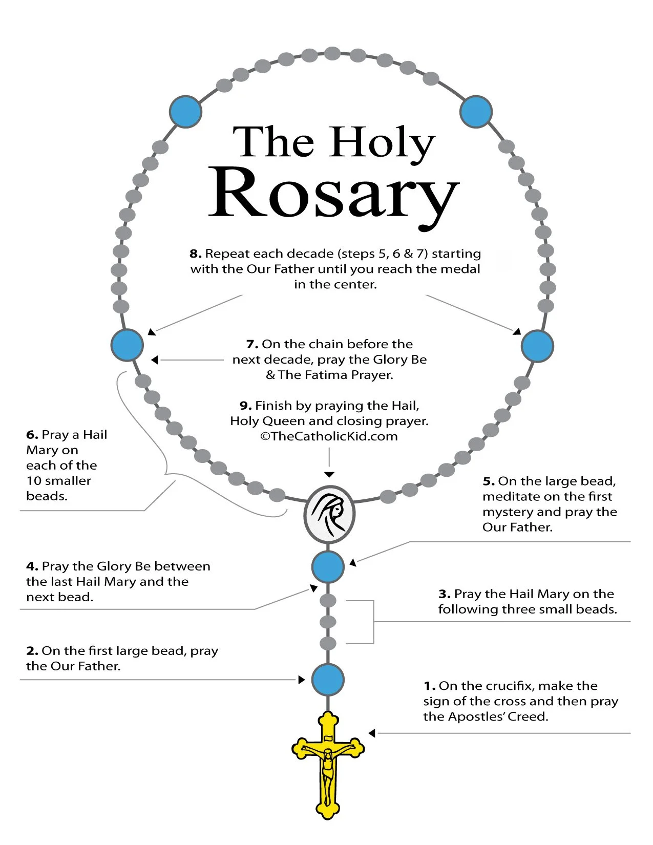

How to Pray the Rosary

1. SAY THESE PRAYERS...
IN THE NAME of the Father, and of the Son, and of the Holy Spirit. Amen. (As you say this, with your right hand touch your forehead when you say Father, touch your breastbone when you say Son, touch your left shoulder when you say Holy, and touch your right shoulder when you say Spirit.)
I BELIEVE IN GOD, the Father almighty, Creator of Heaven and earth. And in Jesus Christ, His only Son, our Lord, Who was conceived by the Holy Spirit, born of the Virgin Mary, suffered under Pontius Pilate; was crucified, died, and was buried. He descended into Hell. The third day He rose again from the dead. He ascended into Heaven, and sits at the right hand of God, the Father almighty. He shall come again to judge the living and the dead. I believe in the Holy Spirit, the holy Catholic Church, the communion of saints, the forgiveness of sins, the resurrection of the body, and life everlasting. Amen.
OUR FATHER, Who art in Heaven, hallowed be Thy Name. Thy kingdom come, Thy will be done on earth as it is in Heaven. Give us this day our daily bread, and forgive us our trespasses, as we forgive those who trespass against us. And lead us not into temptation, but deliver us from evil. Amen.
HAIL MARY, full of grace, the Lord is with thee. Blessed art thou among women, and blessed is the fruit of thy womb, Jesus. Holy Mary, Mother of God, pray for us sinners, now and at the hour of our death. Amen.
GLORY BE to the Father, and to the Son, and to the Holy Spirit. As it was in the beginning is now, and ever shall be, world without end. Amen.
O MY JESUS, forgive us our sins, save us from the fires of Hell; lead all souls to Heaven, especially those in most need of Thy mercy. Amen.
HAIL HOLY QUEEN, mother of mercy; our life, our sweetness, and our hope. To thee do we cry, poor banished children of Eve. To thee do we send up our sighs, mourning and weeping in this vale of tears. Turn, then, most gracious advocate, thine eyes of mercy toward us. And after this, our exile, show unto us the blessed fruit of thy womb, Jesus. O clement, O loving, O sweet Virgin Mary. Pray for us, O holy Mother of God, that we may be made worthy of the promises of Christ. Amen.

O GOD, WHOSE only-begotten Son by His life, death and resurrection, has purchased for us the rewards of eternal life; grant, we beseech Thee, that by meditating upon these mysteries of the Most Holy Rosary of the Blessed Virgin Mary, we may imitate what they contain and obtain what they promise, through the same Christ our Lord. Amen.
ANNOUNCE each mystery by saying something like, “The third Joyful Mystery is the Birth of Our Lord.” This is required only when saying the Rosary in a group.
2. IN THIS ORDER...
INTRODUCTION
1. IN THE NAME...
2. I BELIEVE IN GOD... 3. OUR FATHER...
4. HAIL MARY...
5. HAIL MARY...
6. HAIL MARY...
7. GLORY BE...
8. O MY JESUS...
THE FIRST DECADE
9. ANNOUNCE MYSTERY... 10. OUR FATHER... 11. HAIL MARY... 12. HAIL MARY... 13. HAIL MARY... 14. HAIL MARY... 15. HAIL MARY... 16. HAIL MARY... 17. HAIL MARY... 18. HAIL MARY... 19. HAIL MARY... 20. HAIL MARY... 21. GLORY BE... 22. O MY JESUS...
THE SECOND DECADE
23. ANNOUNCE MYSTERY... 24. OUR FATHER... 25. HAIL MARY... 26. HAIL MARY... 27. HAIL MARY... 28. HAIL MARY... 29. HAIL MARY... 30. HAIL MARY... 31. HAIL MARY... 32. HAIL MARY... 33. HAIL MARY... 34. HAIL MARY... 35. GLORY BE... 36. O MY JESUS...
THE THIRD DECADE
37. ANNOUNCE MYSTERY... 38. OUR FATHER... 39. HAIL MARY... 40. HAIL MARY... 41. HAIL MARY... 42. HAIL MARY... 43. HAIL MARY... 44. HAIL MARY... 45. HAIL MARY... 46. HAIL MARY... 47. HAIL MARY... 48. HAIL MARY... 49. GLORY BE... 50. O MY JESUS...
THE FOURTH DECADE
51. ANNOUNCE MYSTERY... 52. OUR FATHER... 53. HAIL MARY... 54. HAIL MARY... 55. HAIL MARY... 56. HAIL MARY... 57. HAIL MARY... 58. HAIL MARY... 59. HAIL MARY... 60. HAIL MARY... 61. HAIL MARY... 62. HAIL MARY... 63. GLORY BE... 64. O MY JESUS...
THE FIFTH DECADE
65. ANNOUNCE MYSTERY... 66. OUR FATHER... 67. HAIL MARY... 68. HAIL MARY... 69. HAIL MARY... 70. HAIL MARY... 71. HAIL MARY... 72. HAIL MARY... 73. HAIL MARY... 74. HAIL MARY... 75. HAIL MARY... 76. HAIL MARY... 77. GLORY BE... 78. O MY JESUS...
CONCLUSION
79. HAIL HOLY QUEEN... 80. O GOD, WHOSE...
81. IN THE NAME...
3. WHILE TOUCHING THESE BEADS TO KEEP TRACK OF YOUR PROGRESS...
4. AND SILENTLY MEDITATING ON THESE “MYSTERIES”, OR EVENTS FROM THE LIVES OF JESUS AND MARY...
On Monday and Saturday, meditate on the “Joyful Mysteries”
First Decade (Steps 9-22): The Annunciation of Gabriel to Mary (Luke 1:26-38) Second Decade (Steps 23-36): The Visitation of Mary to Elizabeth (Luke 1:39-56) Third Decade (Steps 37-50): The Birth of Our Lord (Luke 2:1-21)
Fourth Decade (Steps 51-64): The Presentation of Our Lord (Luke 2:22-38) Fifth Decade (Steps 65-78): The Finding of Our Lord in the Temple (Luke 2:41-52)
On Thursday, meditate on the “Luminous Mysteries”
First Decade: The Baptism of Our Lord in the River Jordan (Matthew 3:13-16) Second Decade: The Wedding at Cana, when Christ manifested Himself (Jn 2:1-11) Third Decade: The Proclamation of the Kingdom of God (Mark 1:14-15)
Fourth Decade: The Transfiguration of Our Lord (Matthew 17:1-8)
Fifth Decade: The Last Supper, when Our Lord gave us the Holy Eucharist (Mt 26)
On Tuesday and Friday, meditate on the “Sorrowful Mysteries”
First Decade: The Agony of Our Lord in the Garden (Matthew 26:36-56) Second Decade: Our Lord is Scourged at the Pillar (Matthew 27:26) Third Decade: Our Lord is Crowned with Thorns (Matthew 27:27-31) Fourth Decade: Our Lord Carries the Cross to Calvary (Matthew 27:32) Fifth Decade: The Crucifixion of Our Lord (Matthew 27:33-56)

On Wednesday and Sunday, meditate on the “Glorious Mysteries”
First Decade: The Glorious Resurrection of Our Lord (John 20:1-29) Second Decade: The Ascension of Our Lord (Luke 24:36-53)
Third Decade: The Descent of the Holy Spirit at Pentecost (Acts 2:1-41) Fourth Decade: The Assumption of Mary into Heaven Fifth Decade: The Coronation of Mary as Queen of Heaven and Earth
How to recite the Holy Rosary
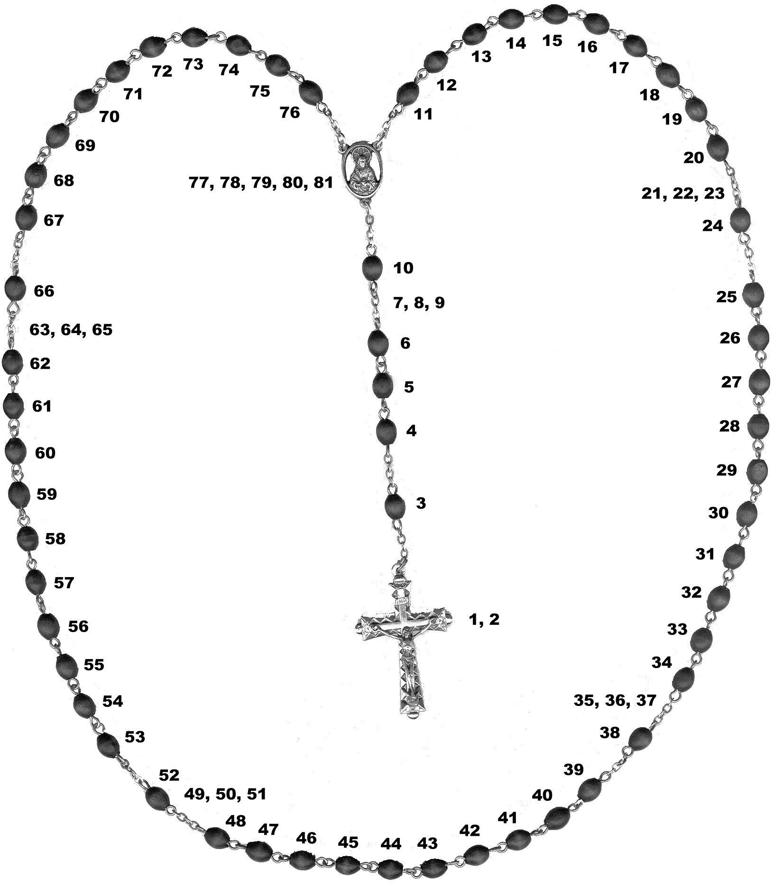
www.newadvent.org

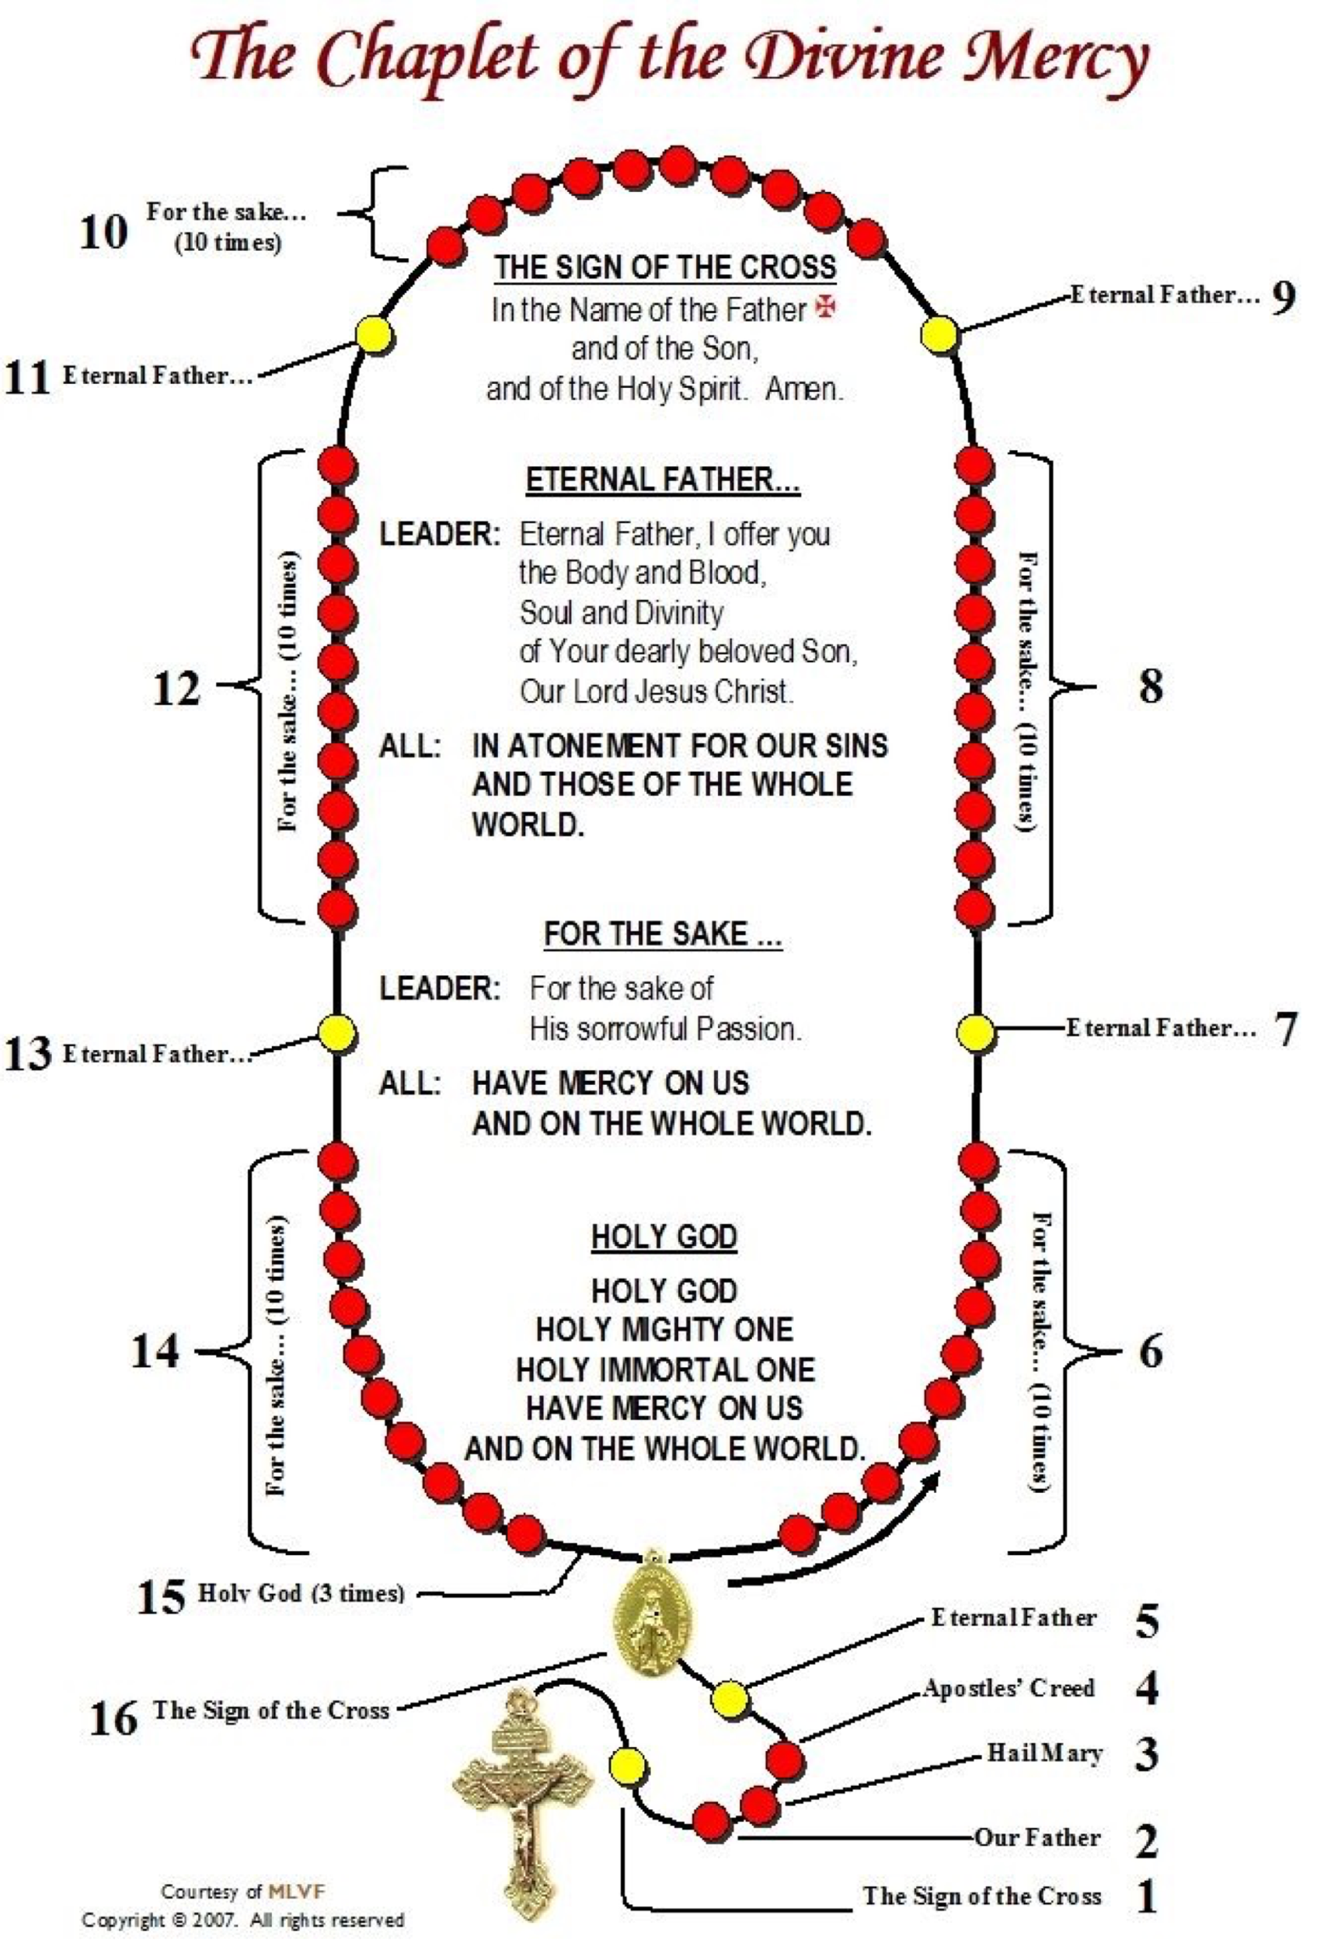

Prayers and Teachings to KNOW

Check the prayers and teachings that you know by heart. Memorize the ones you don’t!

1.The Sign of the Cross
In the name of the Father, and of the Son, and of the Holy
Spirit, Amen.

___2. GRACE BEFORE MEALS Bless us, o Lord, and these thy gifts, which we are about to receive from thy bounty, through Christ, our Lord, Amen.

___3. THE LORD’S PRAYER Our Father, who art in heaven, hallowed be thy name. Thy Kingdom come, thy will be done on earth as it is in heaven.
Give us this day our daily bread, and forgive us our trespasses as we forgive those who trespass against us. And lead us not into temptation, but deliver us from evil. Amen.

___4. HAIL MARY Hail, Mary, Full of grace, the Lord is with thee! Blessed are
you among women and blessed is the fruit of your womb, Jesus. Holy Mary, Mother of God, pray for us sinners, now and at the hour of our death, Amen.

___5. GLORY BE Glory Be to the Father, and to the Son, and to the Holy Spirit,
as it was in the beginning, ever shall be, world without end. Amen.

___ 6. ACT OF CONTRITION

My God, I am sorry for my sins with all my heart. In choosing to do wrong and failing to do good, I have sinned against you whom I should love above all things. I firmly intend, with your help, to do penance, to sin no more, and to avoid whatever leads me to sin. Our Savior Jesus Christ suffered and died for us. In His Name, my God, have mercy. Amen
__7. Rite of Confession Start by making the Sign of the Cross and say: 1. “Bless me Father, for I have sinned. It has been ____ since my last confession, and these are my sins.” 2. Confess your sins. 3. Following your confession, say, “I am sorry for these and all my sins.” 4. Say an act of Contrition. 5. The priest gives you absolution. Say “Amen.” 6. Complete your assigned penance.
__8. TEN COMMANDMENTS 1. I am the Lord, your God. You shall have no other gods besides me. 2. You shall not take the name of the Lord, your God, in vain. 3. Remember to keep holy the Sabbath day. 4. Honor your father and your mother. 5. You shall not kill. 6. You shall not commit adultery. 7. You shall not steal. 8. You shall not bear false witness against your neighbor. 9. You shall not covet your neighbor’s wife. 10. You shall not covet your neighbor’s goods.
SEVEN GIFTS OF THE HOLY SPIRIT
By Laura Jean Rabiipour
9.
The seven gifts are enumerated in Isaiah 11:2-3
The Gift of Wisdom is our ability to value spiritual things over worldly ones. It enables us to desire the things of God and correctly order the things in our life. This gift helps us view the world through God’s perspective and the light of our faith. It instills a desire to contemplate the things of God.
The Gift of Understanding helps us grasp the truths of the faith more easily and profoundly. Our human intellect cannot grasp all of God’s mysteries, but through the gift of understanding we can be lead to truth, even when we do not fully comprehend. This gift strengthens our insight through prayer, scripture, and the sacraments.
The Gift of Right Judgment/Counsel acknowledges the difference between right and wrong and bestows proper judgment. A person with right judgment avoids sin and leads a life for Christ. Counsel inspires us to speak up and encourage others to do the correct thing. It bestows upon us prudence, allowing us to act promptly and rightly in the face of difficult situations.
The Gift of Courage/Fortitude sustains our decision to follow the will of God in any situation. It allows us to stand up and defend our faith, even when threatened by bodily injury or death. This gift allows us to be steadfast in our decisions to do well and to endure evil even when we do not want to.
The Gift of Knowledge is awareness of God’s plan. It is not simply an accumulation of facts, but rather an understanding of God’s purpose and how we ought to respond. Knowledge helps bring to light the temptations that we face, and to discern whether to give in or live a life worthy of God’s approval.
The Gift of Piety or reverence is our obedience to God and our willingness to serve him. It is not just obedience through a sense of duty or obligation, but rather obedience out of love and devotion. It facilitates a deeper respect and honor for God and His Church.
The Gift of Wonder and Awe/Fear of the Lord makes us aware of the glory and majesty of God. This gift is also synonymous with the "Fear of the Lord", in which we dread sin and fear offending God. We fear displeasing God and losing our connection with him because of our love for Him. Wonder and awe increases our desire to draw closer to God and depart from sin.
____10. Order of the Mass
1. Introductory Rites
2. Liturgy of the Word
3. Liturgy of the Eucharist
4. Concluding Rites

___11. Seven Sacraments: Baptism, Confirmation, Eucharist, Reconciliation, Marriage, Holy Orders, Anointing of the Sick

____12. MORNING OFFERING
O my God, I offer You all my prayers, works, joys and sufferings of this day, for all the intentions of Your Sacred Heart, in union with the Holy Sacrifice of the Mass throughout the world, in reparation for my sins, for the intentions of all our associates, and in particular for the intentions of the Holy Father. Amen.

____13. Corporal Works of Mercy
1. Feed the Hungry.
2. Give Drink to the Thirsty.
3. Shelter the Homeless
4. Visit the Sick
5. Visit Prisoners
6. Bury the Dead
7. Give Alms to the Poor

____14. Spiritual Works of Mercy
- Counseling the Doubtful
- Instructing the Ignorant
- Admonishing the Sinner
- Comforting the Sorrowful Forgiving Injuries
- Bearing Wrongs Patiently
- Praying for the Living and Dead

